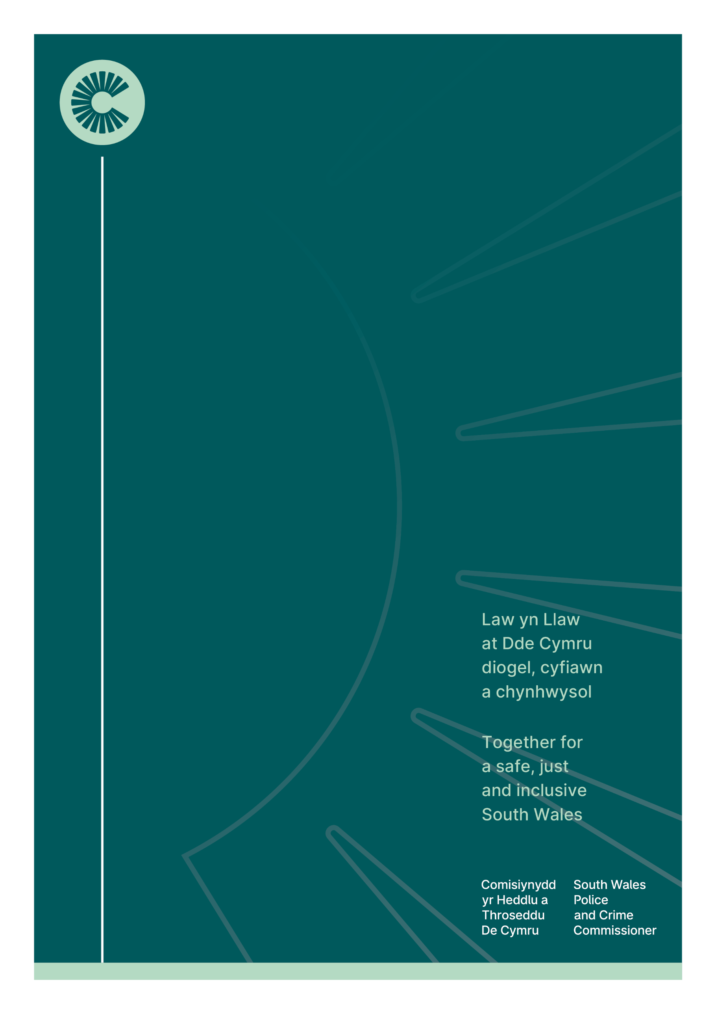

26/03/23

Commissioning of an Independent Sexual Violence Adviser/Advocate (ISVA) service
Commissioning of an Independent Sexual Violence Adviser/Advocate (ISVA) service
Following agreement at a multi-agency Wales Sexual Assault Services (WSAS) Programme meeting in Spring 2023, the offices of the Dyfed Powys, Gwent and South Wales Police and Crime Commissioners’ (OPCCs) are jointly commissioning a Criminal Justice Focussed Independent Sexual Violence Adviser/Advocate (ISVA) Service. The Office of the South Wales Police and Crime Commissioner is leading on the procurement and contract management process on behalf of the other OPCCs.
South Wales OPCC will be utilising existing funding received from Ministry of Justice within the financial envelope for the ISVA service. The intention is to commence commissioning of the new service in Spring/Summer 2024, subject to timescales of completion of necessary implementation and transition activities.
Feedback from services, survivors and key partners has facilitated the development of a service specification to support a consistent offer, clear expectations relating to quality and standards and formal commissioning arrangements that will provide clear monitoring and evaluation opportunities across the regions.
The commissioned ISVA service will have a focus on criminal justice advocacy and support, with wider needs being supported through robust referral pathways to suitable services.

Mae'r ddogfen hon hefyd ar gael yn Gymraeg |This document is also available in Welsh

