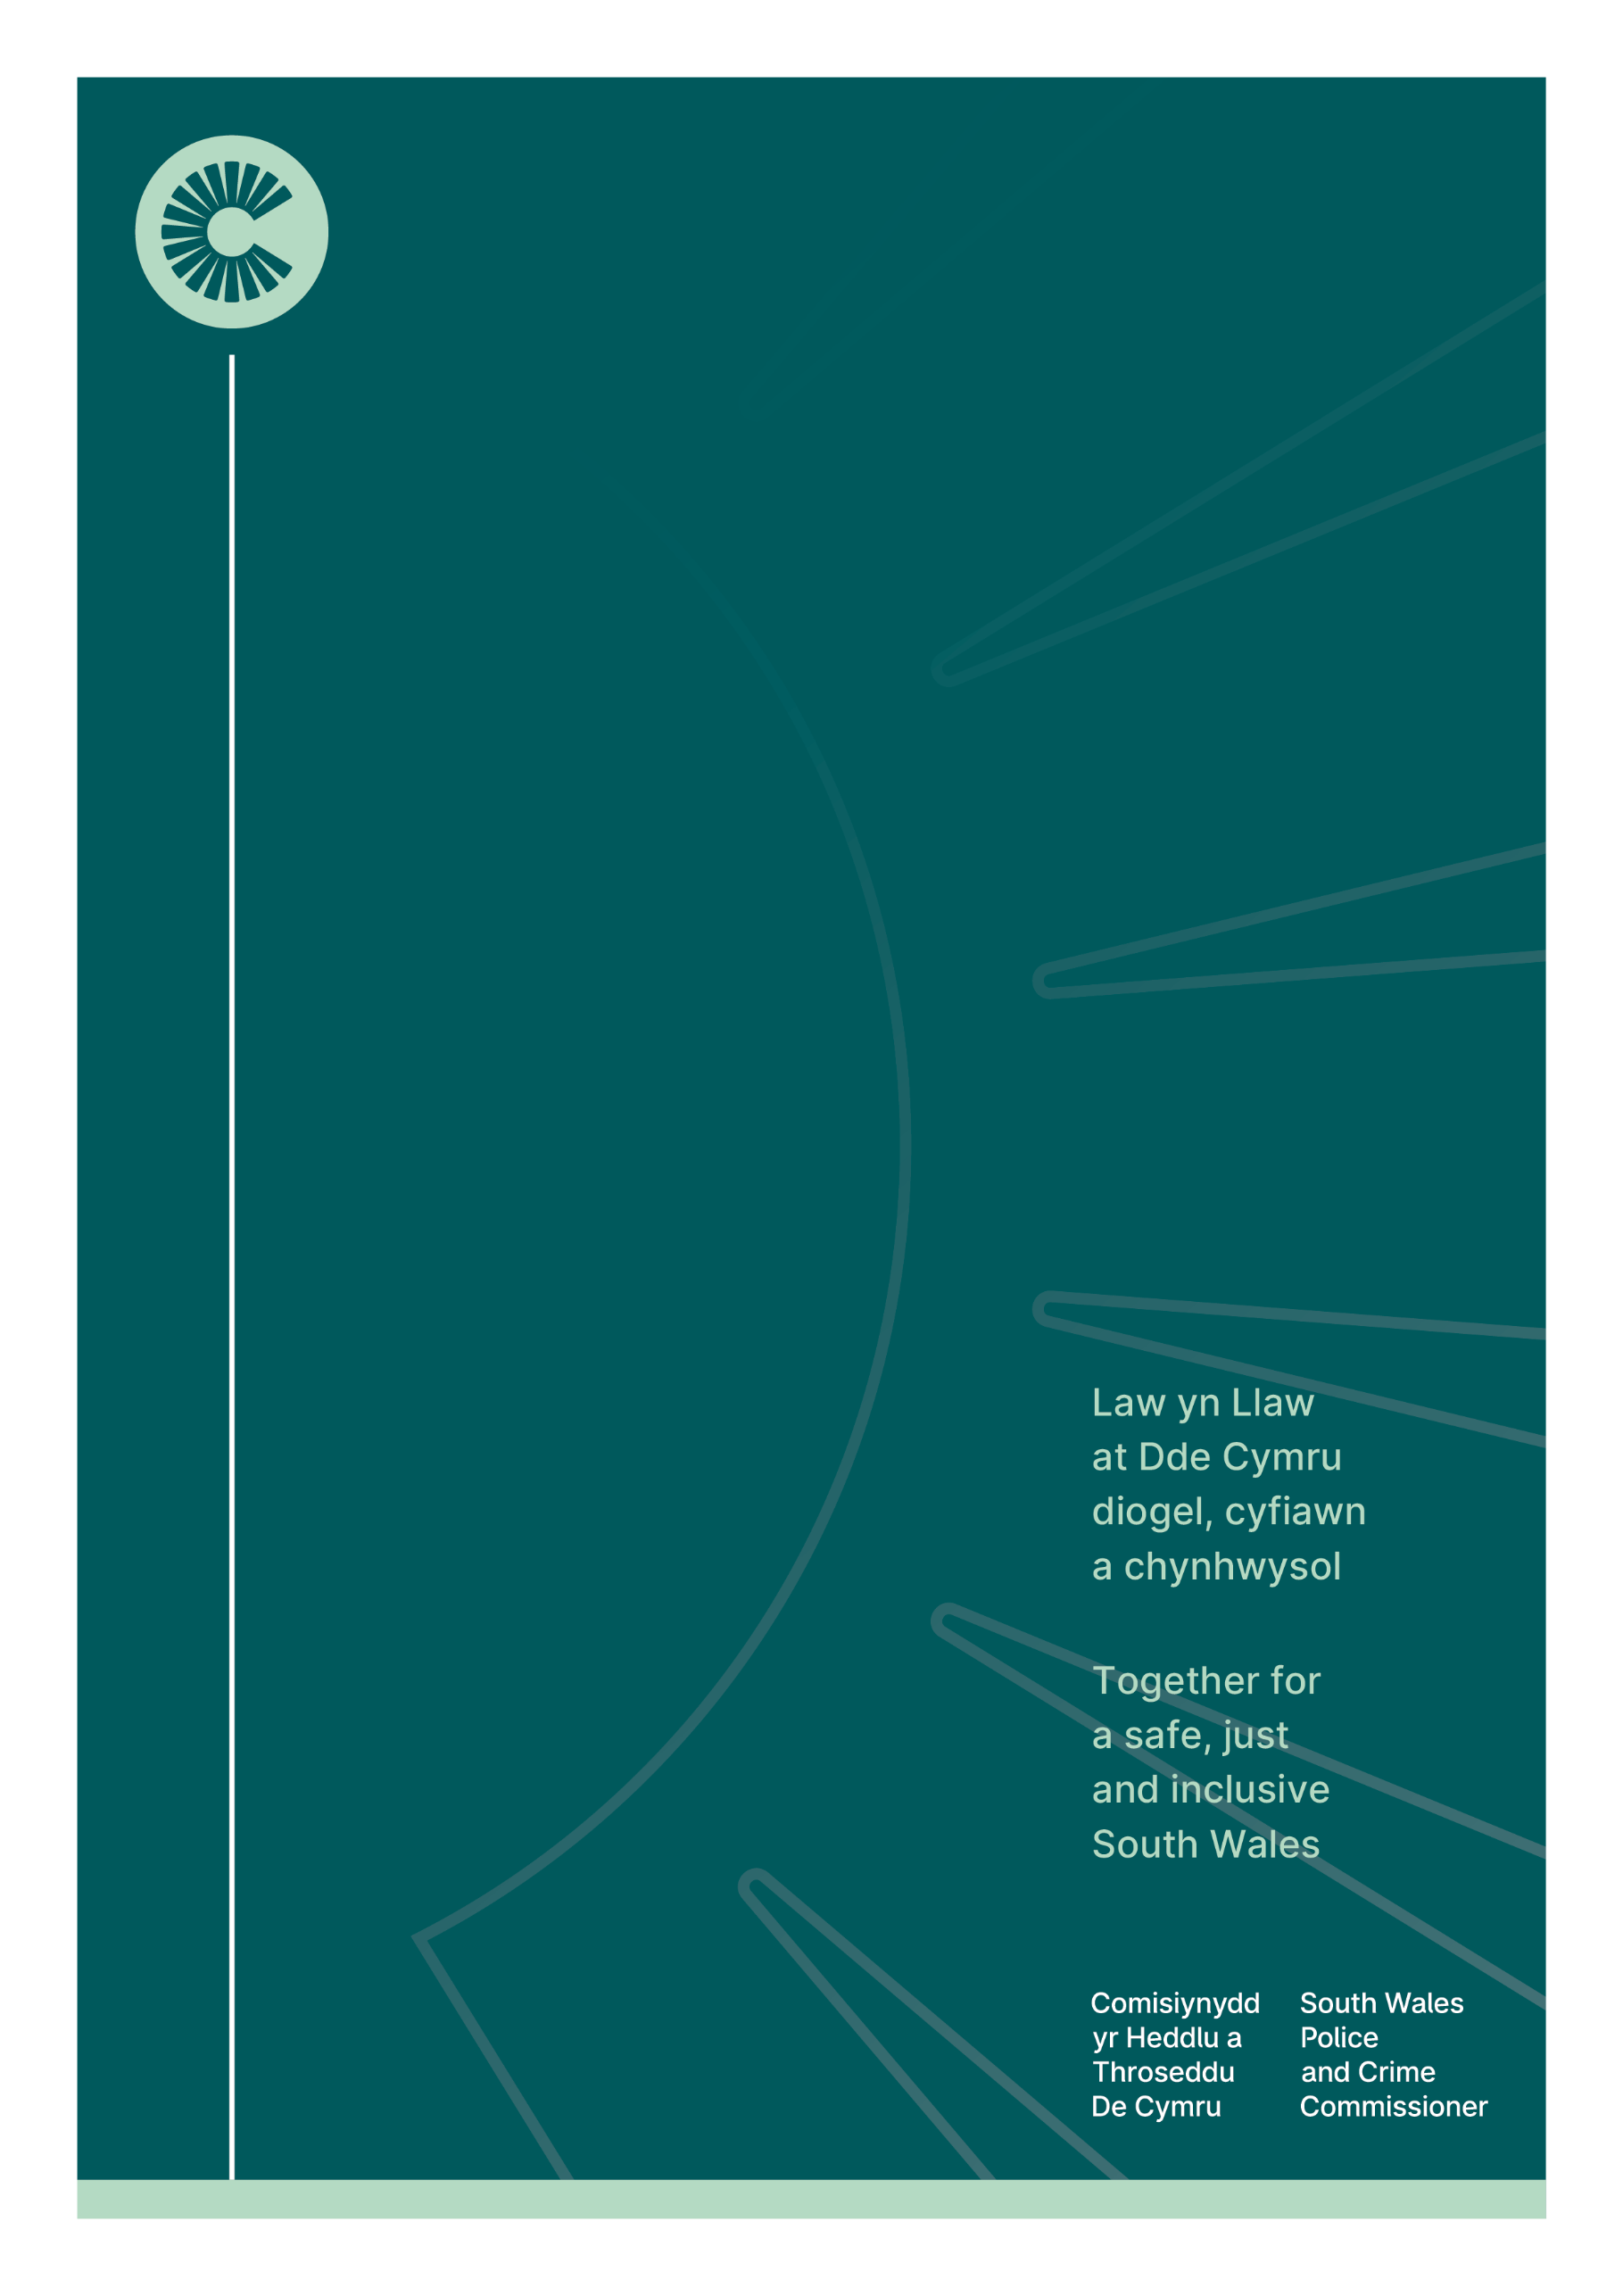

05/2026

Safer Places Partnership Fund

Please read this document carefully.

This will help you decide whether you are eligible to apply to the Police and Crime Commissioner’s Safer Places Partnership Fund, along with all the necessary information to submit your application.

Please read in conjunction with all accompanying documents included within this document.

Contents
- Introduction
- Aim
- Who can apply for funding?
- Grant funding term and maximum award
- How will grant applications be assessed?
- Timeline
- Eligible / Ineligible expenditure
- Grant payments, monitoring and reporting

Introduction
Throughout her term, the Police and Crime Commissioner (PCC) for South Wales has committed to drive and deliver ambitious change across the region. To fulfil this, the PCC has made a commitment to make best use of her resources, including funding, to support innovation and invest in evidence- based, public health approaches that focus on early intervention and prevention to make an impactful difference to communities across South Wales.
With the conclusion of the Home Office Hotspot Action Fund in March 2026, the place-based approach and Operation Sentinel methodology has been transitioned into business as usual within neighbourhood policing, aligned to the Neighbourhood Policing Guarantee and the Chief Constable’s Delivery Plan. Alongside this operational policing transition, the Police and Crime Commissioner has secured £1M funding to support partnership activity during 2026-28 that seeks to prevent crime and reduce violence in areas of focus, identified through data analysis. The Safer Places Partnership Fund will enhance and accelerate activity in identified locations by enabling public sector, private sector and non-government/community/charitable organisations to deliver targeted interventions.
At the heart of the Office of the Police and Crime Commissioner’s (OPCC’s) values is collaboration, and we invite partners when applying for this grant to be ambitious and innovative to support what matters to the people of South Wales and what will make a positive difference to communities.

Aim
The South Wales Police and Crime Commissioner’s Grants Scheme aims to fund projects and services that will build a safer, fairer and more inclusive South Wales.
The funding aims to provide a coherent commissioning and assurance mechanism that strengthens whole-system delivery in places with complex needs and ensures sustained impact beyond time-limited grant arrangements.

The key priority of this funding is to support impactful activity that seeks to tackle one or more of the following through diversion and engagement, early intervention and prevention activity, community safety initiatives and/or partnership-led problem solving aligned to local priorities:
- Violence
- Anti-social behaviour
- Retail crime
- The safety of women and girls in public spaces, particularly at night
- Knife crime
- Child criminal exploitation

Funded activity should seek to support the delivery of local priorities (detailed within local strategies/action plans from Community Safety Partnerships, VAWDASV Boards, Violence Prevention and Reduction Boards, OSARA problem-solving plans, serious violence strategic needs assessments, Anti-Social Behaviour Action Plan).

Projects/services should also aim to support one or more of the priority areas and outcomes set out within the Police, Crime and Justice Plan and/or Children and Young People’s Police, Crime and Justice Plan. Each application will be asked to provide evidence of how they will measure success and impact as well as demonstrating value for money and return on social investment.

Who can apply for funding?
The Police and Crime Commissioner welcomes applications coordinated and submitted by Community Safety Partnerships to support a connected approach that aligns to local need and priorities. Activities included within the planned delivery may represent public sector, private sector and/or non-government organisation inputs. Applications that include community, specialist, by and for and grassroot organisations, where appropriate, will be favourably considered.
Funded activity must be located in one of the data-led 32 areas of focus. Further information can be found here:
Community Safety Leads will be invited to submit grant applications via the flexi grant portal to be considered for funding. The link to the application form can be found here: Safer Places Partnership Fund Application Form.

Grant funding term and maximum award
Applicants are invited to apply for services/projects that may be delivered up until 31 March 2028. Projects that have an earlier end date will also be considered and, subject to funding, additional applications may be submitted in later funding rounds.
When determining award values, consideration will be given to the number of identified areas of focus addressed by the project or service, existing local investment, and the extent to which it delivers against funding priorities and evidence-based need.

Applicants are encouraged to be mindful that the £1 million investment will need to support activity across the 32 locations up to the end of 2028 and so funding requests should be proportionate to the overall scope and duration of the fund.

How will grant applications be assessed?
A dedicated Safer Places Partnership Board has been established with representation across the OPCC and Policing to provide focused operational and strategic oversight of the place-based approach, including reviewing and determining outcomes relating to applications submitted through the Safer Places Partnership Fund.
The proposed project/ service will be assessed based on:
- Alignment to the Fund priorities (see Aim)
- Alignment to local priorities (local strategies, needs assessments and/or action plans)
- Alignment to the South Wales Police Crime and Justice Plan and/or Children and Young People’s Police Crime and Justice Plan
- Taking a new and innovative approach outside of any business as usual activity
- Evidence-base (including any gap analysis, evidence of local need)
- Intended outcomes/impact and commitment to monitoring disproportionality and taking mitigating actions where appropriate.
- Engagement with key stakeholders prior to application and ongoing plans to continue engagement to support a collaborative approach, including engagement with communities and/or children and young people; and consideration of community and grassroot organisations within delivery plans
- Responsivity to local community demographics and the diverse needs of the local area.
- Effective and efficient use of resources and a clear sustainability plan
- Evidence of robust finance and oversight mechanisms for transparency of the use of public money

Timeline

Funding Round 1 – Summer 2026
Applications open | 22 May 2026
Applications close | 26 June 2026
Award notification | 17 July 2026
Funding Round 2 – Autumn 2026
Applications open | 11 September 2026
Applications close | 23 October 2026
Award notification | 20 November 2026
Funding Round 3 – Spring 2027 (subject to level of funding remaining)
Applications open | January
Applications close | February
Award notification | March

Please note, if your application is not received, is late or incomplete and cannot be considered at the Safer Places Partnership Board meeting, it may not be considered until a future funding round.

Eligible / Ineligible expenditure
Eligible expenditure | Ineligible expenditure
Expenditure for the project/ service including, but not limited to:  - Salaries  - Running costs  - Equipment | - Commercial ventures and premises.  - Capital infrastructure, including CCTV and lighting.  - Management charges of any kind.  - Projects that unnecessarily duplicate activity already funded by the PCC, local authorities or other funders.  - Religious and / or political activity.  - Funding of statutory staff posts/ statutory functions.

Grant payments, monitoring and reporting
Grant awarded projects/services will receive payments in quarterly intervals unless requested and agreed otherwise and will be subject to the signed return of Grant Terms and Conditions, and ongoing receipt and approval of quarterly monitoring reports. Late submissions of monitoring reports and other reporting will be escalated to the OPCC’s Senior Leadership Team and the equivalent within the applicant’s organisation.
As part of the terms and conditions of the grant, monitoring and reporting will be required throughout the duration of the grant funding period. Community Safety Partnerships will be required to coordinate quarterly monitoring returns and an end of year monitoring report via the flexi grant portal. Copies of these monitoring reports will be made available at the point of grant award and will include data relating to project/service outcome/success measures.
Please be advised, the OPCC may also undertake deep dives into funded services and projects to better understand impact and effectiveness and to support future policy design and implementation, partnering with academic institutions where appropriate, to undertake evaluations to better understand what works. If your service is selected, we shall work collaboratively with you around any evaluation work carried out.
Successful grant recipients shall:
(a) include an acknowledgement that the Commissioner has provided the Grant and display the logo of the Commissioner on all marketing and/or publicity materials that may be used to promote the award or use of the Grant,
(b) invite the Commissioner to have comment in any press releases prior to their release, in respect of the award or use of the Grant, and
(c) participate in PCC led communications activity where requested.

Hot spot policing in England and Wales, year ending March 2023: Evaluation of Grip and bespoke-funded hot spot policing - GOV.UK

